MEDO LUTHERAN CHURCH
14193 626th Ave.
Mapleton, MN. 56065

September 2017

RALLY SUNDAY
September 10th
POTLUCK!!!!!

MEDO MESSENGER September 2017
Summer is coming to a close and it’s time to look ahead to our program year and what God is up to here at Medo Lutheran Church. As I said in worship last week, the second Sunday of each September for the past five years has been God’s Work, Our Hands Sunday and the ELCA has encouraged member churches to participate. The idea is that the congregations plan and live out their mission right in their own community. It’s a push to let our bodies be “living sacrifices” for our Savior.
Churches do all sorts of activities, from make meals for the sick and homebound, to spend the day building houses with Habitat for Humanity. The hope is that we have activities that both the youngest and oldest members can help with. We are in the process of putting together such activities here at Medo Lutheran Church for after worship on our Rally Sunday, September 10th. The younger, Sunday School group are going to be coloring patriotic pictures. Our older members, and others, will be asked to write letters to veterans who are living in veteran’s homes. We’ll put them together and mail them to a local veteran’s home. We are still working out what our able-bodied folks will do. One suggestion is to do some clean up around the Pemberton Plaza. All ideas are welcome! Contact Pastor Patrick Ziems, 320/221-1746.
Another task that Medo Lutheran needs your help with is our Church Constitution. I am updating the Medo Lutheran Constitution. It’s a big task but I’m almost done with the first draft. I need 2-3 people to work on a Constitution Committee to help make sure the intent of the old Constitution from 1998 gets passed on to the new one. If you would like to help with this get a hold of Pastor Patrick Ziems.
As we move ahead with these tasks we need to keep in mind that this is the work of the whole church. Ephesians 2:19-22 So then you are no longer strangers and aliens, but you are fellow citizens with the saints, and are of God's household, having been built on the foundation of the apostles and prophets, Christ Jesus Himself being the corner stone, in whom the whole building, being fitted together, is growing into a holy temple in the Lord, in whom you also are being built together into a dwelling of God in the Spirit.
It's God’s Spirit that keeps us moving forward. What are we up to here at Medo Lutheran? Every day, every week we listen to God and act on his plan for our lives. We live our lives together as the Body of Christ and we look to the cornerstone of our faith, Jesus, to guide us on our path of service, because Christ first served us.
See ya on Sunday,
Pastor Patrick Ziems
IN OUR THOUGHTS AND PRAYERS
Dear Lord may your Light shine on those who are troubled in mind, body, or spirit. Heal them, comfort them, and let them feel the strength of your loving arms. Amen.
We pray especially for: Melinda Kirksey, Larry Buckholtz, Ruthie Hodgkins Mathews, Vi Baumann, Kay Bleess, and others we name in our hearts.
We also pray for our service men and women. We especially pray for Chris Bjornson, currently stationed in Paris, France.

NEED PASTORAL CARE?
If you are in need of pastoral care, please contact Pastor Patrick, Dave, or Sue or any other council member. Other members of the council are Dave and Jennifer Meyer, Josh Isebrand, Ruby Isebrand, Rich Ostendorf, Paul Knutson, and Caitlyn Wakefield.
Pastor Patrick Ziems – Phone: 320.221.1746
Email: pastorpatrickziems@gmail.com
Church office: 507.869.3056
Dave Isebrand at 507.869.3161 or 507.779.9060
Susan Splinter at 507.869.3707 or 507.380.9583
MEDO and Social MEDIA
Medo now has an “official” Facebook page! Look us up! For help finding us – https://www.facebook.com/Medo-Lutheran-Church-1620606911291857/. Medo also has a web site now – check it out! Our email address is: medolutheranchurch@gmail.com. We also still have a regular LAND line – 507.869.3056. The phone numbers for the Pastor and 2 council members are also listed above. Medo wants to be available to you in as many ways as possible. Keep watch!

“When we see others as the enemy, we risk becoming what we hate. When we oppress others, we end up oppressing ourselves. All of our humanity is dependent upon recognizing the humanity in others.”
― Desmond Tutu
RALLY SUNDAY – September 10th
Sunday, September 10, 2017 is the kick off to our church year. Since this is the second Sunday of the month – our service will be held at the Pemberton Plaza. We will have worship and communion at 9:00 a.m. At 10:00 a.m. – we will have several activities – some of our youth will be working on a coloring project, adults will be writing letters to veterans, other adults and kids will be working on a community project. September 10th is also “GOD’S WORK, OUR HANDS” Sunday. In keeping with this we will be cleaning up the grounds around the Plaza, weeding the flower/landscape areas, and even cleaning the door glass. We have chosen this project as a way of thanking the City of Pemberton for agreeing to let us utilize the Plaza as a worship space. Once this is completed we will gather for a potluck meal! Please bring your neighbor, bring a friend. Bring a dish to pass as you are able – don’t worry if you can’t – there is usually plenty of food! Plan to join us!!!
WELCOMING CHILDREN AT MEDO LUTHERAN
As our church year begins, we welcome everyone back! School begins and the Sunday school year begins.
To the parents of our young children may we suggest:
Relax! God put the wiggle in children; don’t feel like you have to suppress it in God’s house. All are welcome!
Sit toward the front where it’s easier for your little ones to see and hear what’s going on. They tire of seeing the backs of others’ heads.
Quietly explain the parts of the Service and the actions of the pastor, ushers, readers, etc. They might even be asked to ring the bell with help!
Sing the hymns, pray, and voice the responses. Children learn liturgical behavior by copying you.
If you have to leave the Service with your child feel free to do so, but come back. As Jesus said, “Let the little children come to me.”
Remember that the way we welcome children in the church directly reflects on the way they respond to the Church, to God, and to one another. Let them know that they are at home in this house of worship.
To the members of our church
The presence of children is a gift to our church, and they are a reminder that our church is alive and growing. Please welcome our children and give a smile of encouragement to their parents
“Let the little children come to me.”

SOMETHING NEW HAS BEEN ADDED!
As you know, we have worship at the Pemberton Plaza the second Sunday of each month. We welcome the community (all faiths). We share worship and communion, great music, and fellowship. We are going to add something new – we will now also share a meal! Invite your neighbors and friends to join us! If you are able – bring a dish to pass. See you in church and at the Plaza!

SCHOOL AND SUNDAY SCHOOL BEGIN
Please be aware of the beginning of the school year – students will be walking to the bus or to school – drive carefully!
We pray for the teachers – both those in the school system and those who will be teaching the youth of our church. May God bless them in the work that they are doing – they are teaching those who will be leading us in the future. What an awesome challenge they have chosen to pursue!

VACATION BIBLE SCHOOL A SUCCESS!
Our thanks, to Caitlyn, Kylie, and Sherrie Wakefield for teaching Vacation Bible School this year. The children learned about Joshua and the walls of Jericho tumbling down, David and Goliath, and Daniel in the lion’s den. Thanks to the students for sharing their stories and songs during worship on August 20th!

Thank you to all who have generously donated to the events sponsored by Medo during the Pemberton Summer Fest weekend. Thanks to the kitchen crew, float & parade crew, Silent Auction crew, the donations from area businesses, neighbors, former members of Medo and all the members of Medo for your support to make a successful weekend. Also to Thrivent for the $250 Action grant and to Sam’s Club for their donation. God has richly blessed Medo with opportunities to share our faith with our community.
A special thanks to Ruby Isebrand and Richard Ostendorf for organizing the events and to Knudson family for creating the float for the parade.
Also – Congratulations to LeRoy and Theresa Knudson who were selected as the Grand Marshals for the parade.
See some of the picture memories of the Summer weekend.
The results from the Summer Fest weekend are as follows:
Pancake Breakfast - $370
Silent Auction - $1669
Rummage sale & pies - $174
Total to date: $2213
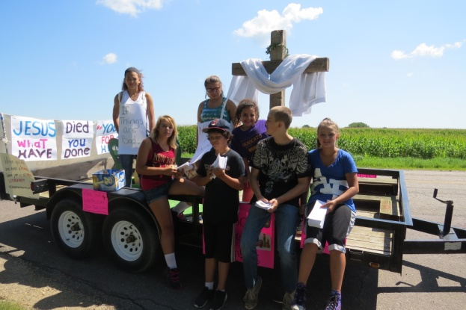
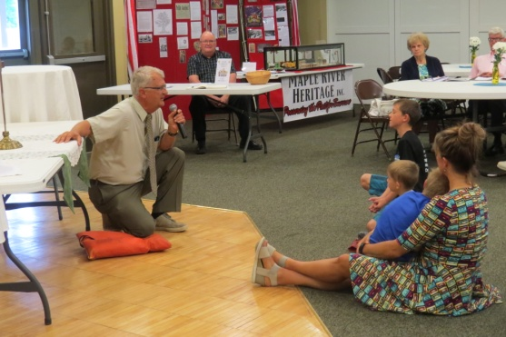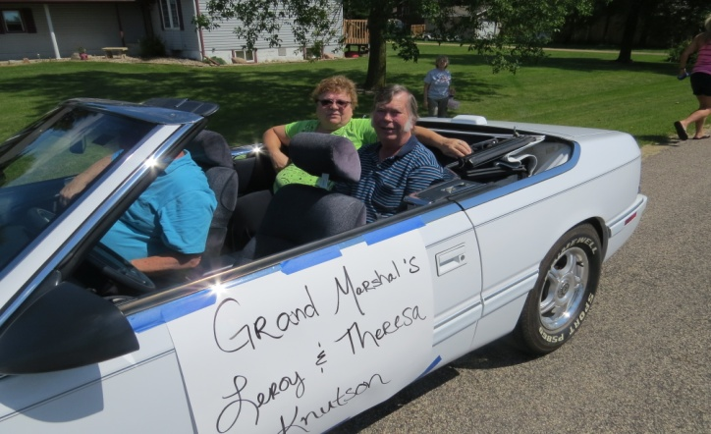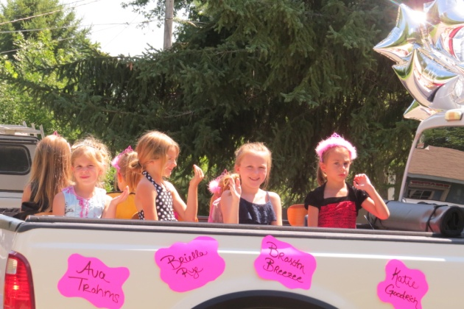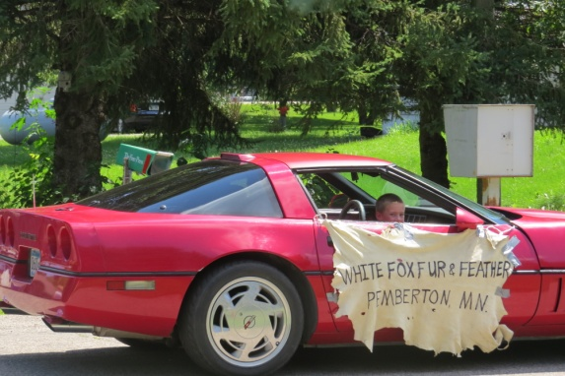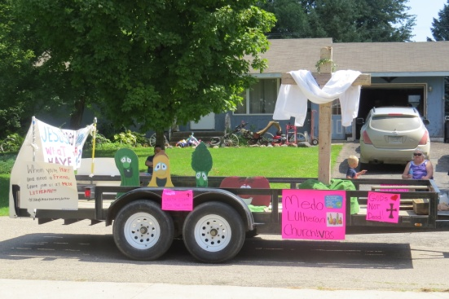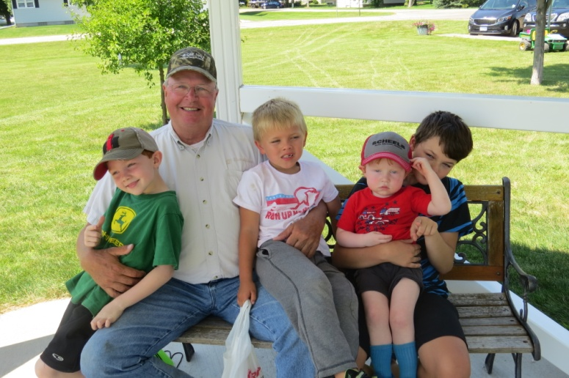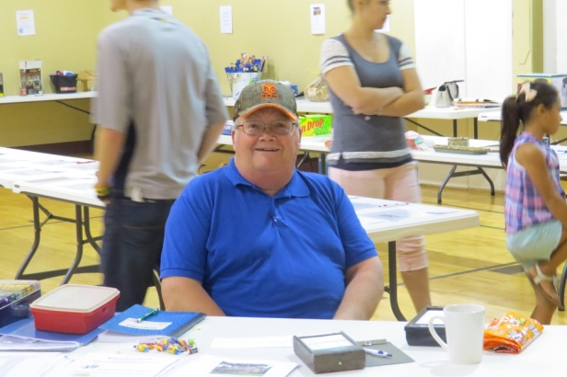
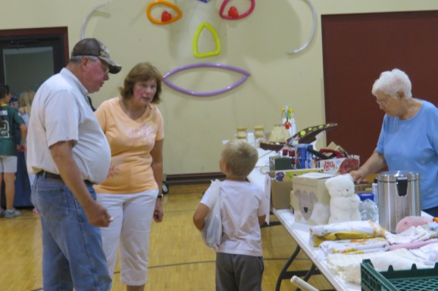

YOUR HELP AND INPUT ARE NEEDED!
Work on updating our Medo Constitution has begun – we are in need of 2 or 3 people to work with Pastor Patrick at reviewing those parts that are specific to Medo. This should involve only a few hours of work to complete.
Secondly – and very importantly – we are in need of at least 5 people who would like to participate in a Call Committee – yes, we are ready to take that step!! We hope to have a balance between young (at least confirmed) and old, male and female. Pastor Patrick and one council member will assist the committee in their work.
Please pray and consider how you may be a part of this important work for our church! Volunteer!
September Birthdays and Anniversaries

September Birthdays September Anniversaries
8 Teresa Knutson 8 Gregg and Jeannie Rollins
9 Courtney Wangen 13 Greg and Shelly (Gunsolus)Dembowski
Carson Goodrich Dave and Jennifer Meyer
13 Sandy (Schubbe) Walsh 14 Lance and Sherrie Wakefield
Robert Young Michael and Toni Jo (Bach) Haus
13 Tina Hassing 15 Larry and Sandy Walsh
16 Elnore Lindeland 21 Erik and Crystal Anderson
18 Layne Janike
20 Tanah Janike
21 Autumn Haug
24 Harlan Proehl
25 Paul Knutson
Jeannie Rollins
28 Jeff Gunsolus

HURRICANE HARVEY
Hurricane Harvey has brought devastation to many people. We pray earnestly for their safety and recovery. There are several local efforts to bring support to them, to ease the suffering in any way. A former Medo member – Kari Dierks (daughter of Gary and Kathy Dierks) lives in Houston. She has volunteered in a shelter and is getting ready to welcome students back to her classroom. She has been fortunate to still have a dry house and little damage. She is thankful for our prayers and asks that we continue to pray for those that have found themselves in the path of Harvey.
THE 500TH ANNIVERSARY OF THE REFORMATION
Our story of the Reformation continues… In Denmark, too, the Reformation came early. As in Sweden, it was led by a young man who had studied under Luther in Wittenberg- Hans Tausen. The ruler at the time, Frederick I, was formally opposed to Reformation ideas, but he protected Tausen and tolerated Lutheran writings. The next king, Christian III, stripped the Roman catholic church of its wealth, and Luther’s pastor, Johannes Bugenhagen, made a journey from Wittenberg to crown the king and help organize the Danish church.
Norway was, at the time, ruled by Denmark, and initially the spread of the Reformation there was slower. Christian III tried to encourage its growth there, but at first there wasn’t much popular support; it was more of a top-down reformation. Nevertheless, pastors such as Jorgen Eriksson, who would become bishop of Stavanger, preached Lutheran teachings, and the Reformation gradually took hold.
Mikael Agricola was yet another student of Luther, and it was he who led the Reformation in Finland. At that time, Finland was ruled by Sweden. The first Lutheran bishop of Turku (and thus of Finland), Martinus Skytte, left most Roman Catholic orders in place. Agricola’s ministry as the next bishop, though, mirrored much of Luther’s; He translated the New Testament into Finnish, and in the process created the Finnish literary language. He prepared a prayer book in Finnish, created a vernacular order of communion, and collected Finnish hymns. He was also the first married bishop of Turku.
To be continued… (taken from a handout done by Augsburg Fortress)
Medo has two students who will soon be confirmed into their Lutheran Faith. Please keep these students in your prayers and watch for the date of confirmation so that you can be there to accept them as they affirm their faith!
